Answers to Objective Questions
- What is the total no. of tables present in the data?
Approach Used:
Opened the dataset in Excel and verified the sheets available. Each sheet represents a unique data table.

Final Answer:
There are 2 tables —
- Raw Data
- Country Description Data

- What is the total no. of attributes present in the data?
Approach Used:
Checked the header row in the “Raw Data” table. Counted the number of unique fields (columns) that represent attributes.
Final Answer:
The dataset contains multiple attribute types:
- Integral / Integer Data
- Float / Decimal Data
- String / Text Data

- How many categorical columns are there in the data? [Search about categorical and continuous data, and try to answer this question]
Approach Used:
Identified categorical variables — columns with qualitative (non-numeric) values such as “Yes/No”, “City”, “Country”, etc.
Final Answer:
Categorical Columns include:
- Country Code / Country Name
- City
- Currency
- Has Table Booking (Yes/No)
- Has Online Delivery (Yes/No)
- Is Delivering Now (Yes/No)
- Switch to Order Menu (Yes/No)
- Price Range (1 to 4)
- The data consists of some inconsistent and missing values so ensure that the data used for further analysis is cleaned.
Approach Used:
Used Excel’s data cleaning tools and logical formulas to handle blanks, outliers, and inconsistent entries.
Final Answer:
- Blank cells were filled using AVERAGE .For numeric fields like Latitude/Longitude similar city reference was taken .
=IF(ISBLANK([@Longitude]),IFERROR(AVERAGEIFS(Table1[Longitude],Table1[City],[@City]),""),[@Longitude])
=IF(ISBLANK([@Latitude]),IFERROR(AVERAGEIFS(Table1[Latitude],Table1[City],[@City]),""),[@Latitude])
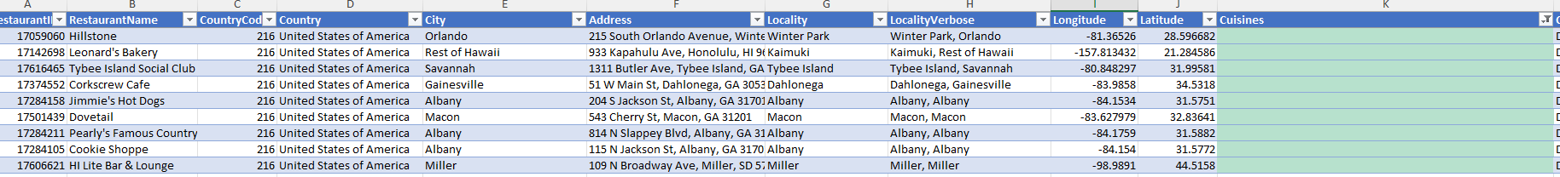
- Missing cuisine entries(9 rows) were deleted.
- Added new calculated columns such as Average Cost for Two (INR) for standardized comparison.
→ Formula :
=MID([@Currency],FIND("(",[@Currency])+1,FIND(")",[@Currency])-FIND("(",[@Currency])-1)&" "&S2
=XLOOKUP([@CountryCode],'country description'!$A$2:$A$16,'country description'!$C$2:$C$16,,0)*[@[Average-Cost-for-two]]
- Using the LookUp functions, fill up the countries in the original data using the country code.

Approach Used:
Used Excel XLOOKUP to map country names from the “Country Description” table into the main data.
Final Answer:
Formula:
=XLOOKUP(C2,'country description'!$A$2:$A$16,'country description'!$B$2:$B$16,,0)
Reference Screenshot :
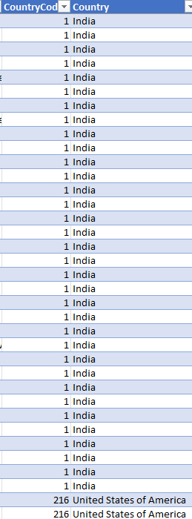

- Create a table to represent the number of restaurants opened in each country.
Approach Used:
Used Pivot Table with “Country” as Rows and “Restaurant ID” (or unique identifier) as Count of Restaurants.
Final Answer:
Country | Number of restaurants opened
Australia | 24
Brazil | 60
Canada | 4
India | 8652
Indonesia | 21
New Zealand | 40
Philippines | 22
Qatar | 20
Singapore | 20
South Africa | 60
Sri Lanka | 20
Turkey | 34
United Arab Emirates | 60
United Kingdom | 80
United States of America | 434
Grand Total | 9551

- Also, the management wants to look at the number of restaurants opened each year, so provide them with something here.
Approach Used:
Used Number of Restaurant IDs in values column in Pivot Table grouped by year of establishment.
- Final Answer:
Year | Number of restaurants opened
2010 | 1080
2011 | 1098
2012 | 1022
2013 | 1061
2014 | 1051
2015 | 1024
2016 | 1027
2017 | 1086
2018 | 1102
Grand Total | 9551

- What is the total number of restaurants in India in the price range of 4?
Ans.
Approach Used:
Used Pivot Table . Country column for Rows and number of Restaurant IDs for Values and Price range as filters.
Final Answer:
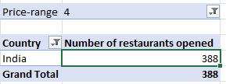

- What is the average number of voters for the restaurants in each country according to the data?
Approach Used:
Created Pivot Table → Rows: Country, Values: Average of Votes.
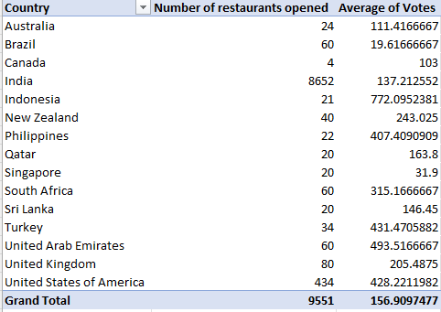

- Calculate the average rating for all the restaurants that have price_range < 4 and provide online delivery. Use only the “IF” function, Logical Operators, and Aggregation functions to solve this problem. [Note: Don’t use Conditional aggregation in this question.]
Approach Used:
Used AVERAGE nested inside IF logical conditions and an “&” operator to calculate mean only when both conditions are met.
Final Answer:
=AVERAGE(IF((Table1[Price-range]<4)*(Table1[Has-Online-delivery]="Yes"), Table1[Rating]))
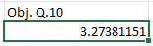
- Using Conditional formatting highlight the rows of restaurants that are located in the countries or cities that you’ve suggested to the management for opening new restaurants.
Approach Used:
Used Excel → Home → Conditional Formatting → “New Rule” → “Cell value contains” to highlight specific countries.
Final Answer :
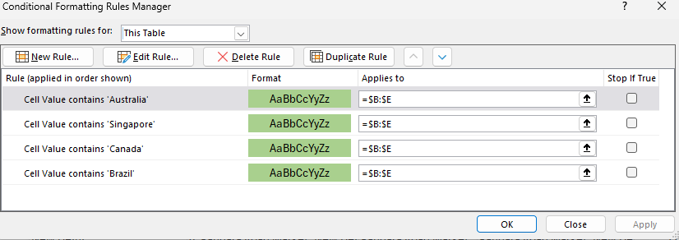
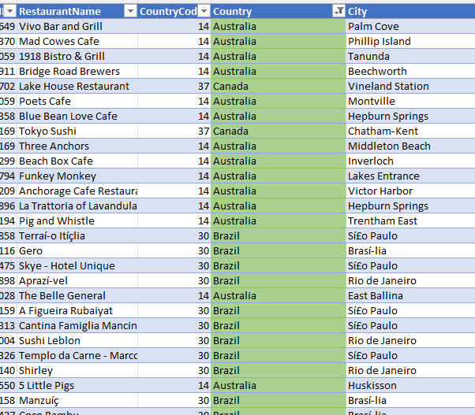
- Create a new customized price column that consists of the abbreviation/symbol of the currency along with the Average_cost_for_two value. [Use string operations to do this task]
Approach Used:
Used functions such as MID() , FIND() and logical operators like ‘&’ to extract currency symbols from currency column.
Formula and Final Answer :
=MID([@Currency],FIND("(",[@Currency])+1,FIND(")",[@Currency])-FIND("(",[@Currency])-1)&" "&S2
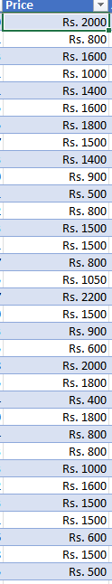

13) How can you create an array formula in Excel or Google Sheets to count the number of restaurants listed that do not offer online delivery, are in the lowest price range, and have an average cost for two people less than or equal to 250 Indian Rupees?
Approach Used:
Used Excel’s COUNTIFS with multiple logical conditions.
Final Answer :
=COUNTIFS(Table1[Has-Online-delivery],"No",Table1[Price-range],"=1",Table1[Price2],"<=250")
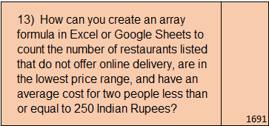
(A few rows were deleted during the cleaning process so the Answer 1694 is not coming , only a close number of 1691)

Answers to subjective questions

  - Suggest a few countries where the team can open newer restaurants with lesser competition. Which visualization/technique will you use here to justify the suggestions?

Approach
- Created a Pivot Table summarizing each country’s:
  - Average Rating
  - Average Price-range
  - Average Cost-for-two (INR)
  - Average Votes
  - % Availability of Table Booking and Online Delivery
Used metrics to identify countries having:
- Average Rating – to understand customer satisfaction levels.
- Average Price Range and Average Cost-for-two (INR) – to assess spending patterns and affordability.
- Average Votes – as an indicator of customer engagement or restaurant popularity.
- Percent availability of Online Delivery and Table Booking – as a measure of market digital maturity and competition.
Visualization technique used:
Clustered Column Chart
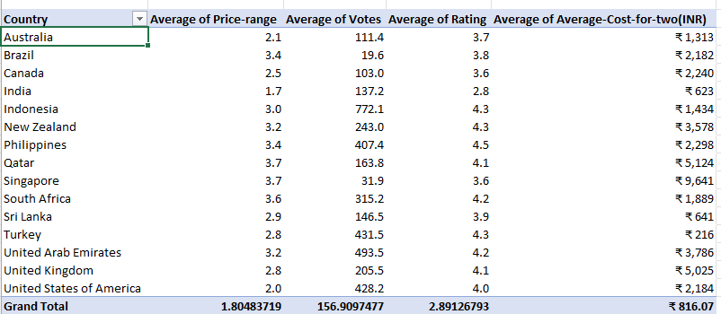

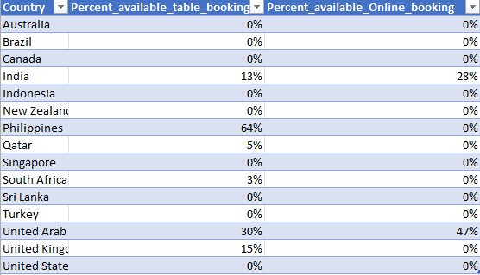

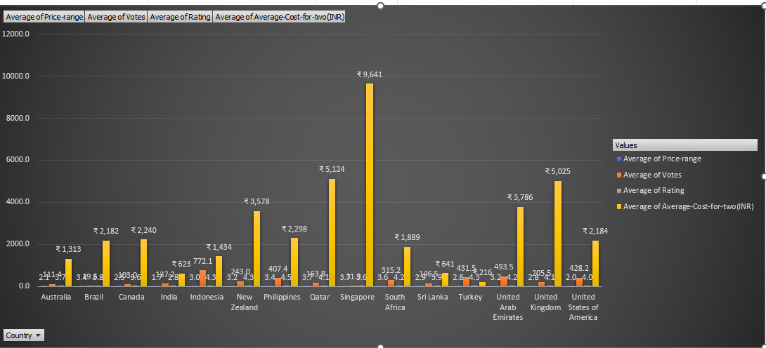

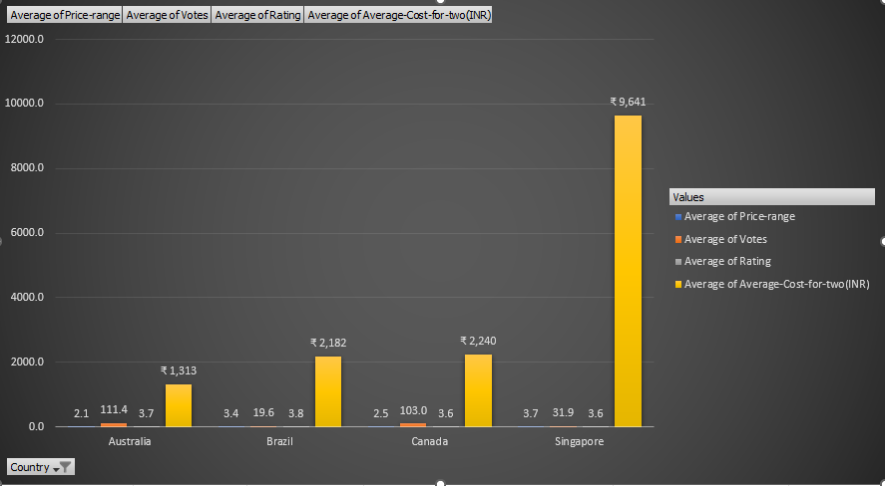

Insights

- Brazil (Avg Rating 3.8, Price 3.4, Cost ₹2,182) → High rating with moderate cost; low booking/delivery penetration → under-served.
- Canada (3.6 rating, ₹2,240) → Fewer restaurants, decent affordability, zero online/table booking → good new-entry potential.
- Australia (3.7 rating, ₹1,313) → Moderate rating, low competition, affordable cost, zero online/table booking → good new-entry potential.
- Singapore (3.6 rating, ₹9,641) → High cost but consistently good rating; niche premium opportunity, same delivery conditions as others.
- Countries like India and Philippines already have higher % online delivery or table booking, implying mature/competitive markets.

Recommendations / Suggestions
- Primary Expansion Targets:
  - Brazil, Canada, and Australia should be prioritized for immediate expansion due to their favorable combination of high ratings, affordability, and minimal competition.
  - Focus on opening limited outlets initially to assess customer preferences, gradually increasing presence based on response and demand trends.
- Secondary Opportunity:
  - Singapore offers potential for establishing a premium or flagship restaurant model targeting high-income urban customers.
- Operational Suggestions:
  - Introduce online delivery and reservation systems in these underdeveloped markets to gain early technological advantage and set brand differentiation.
  - Partner with local delivery platforms where available to build brand visibility faster.
  - Conduct market research on local cuisines and adapt menu items to suit regional tastes while maintaining global brand identity.
  - Ensure a cost–value balance that matches local purchasing power, particularly in Brazil and Canada.
  - Develop marketing campaigns centered on accessibility, affordability, and service quality to attract early adopters.
  - Perform pilot restaurant testing in one key city per country to validate feasibility before nationwide rollout.

Q2) Come up with the names of States and cities in the suggested countries suitable for opening restaurants.
Approach
- Filtered the dataset to the shortlisted countries identified - Brazil, Canada, Australia, and Singapore.
- Created a Pivot Table with Country as the primary filter and City as rows.
- Summarized for each city:
  - Average Rating
  - Average Cost-for-two (INR)
  - Average Price Range
  - Votes (as a proxy for customer activity and engagement).
Ranked cities based on three weighted criteria:
- High average rating (≥ 3.5)
- Moderate to high cost-for-two (affordable yet profitable)
- Fewer restaurants (indicating lower competition).
- Used this multi-criteria approach to identify the most promising urban or regional markets within the shortlisted countries.

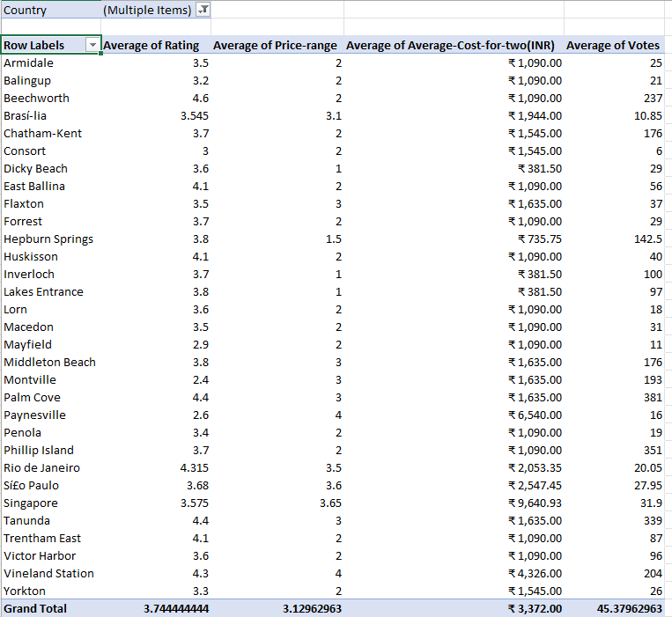
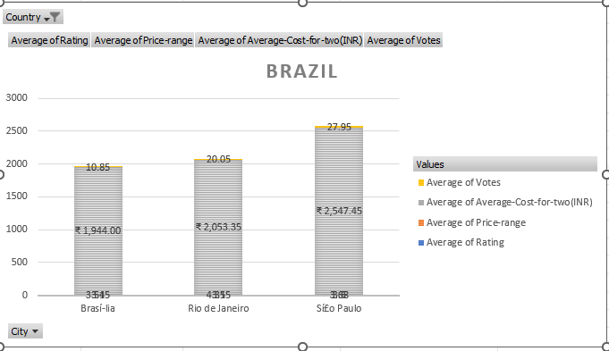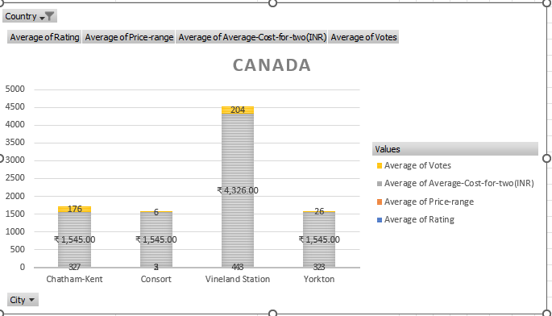
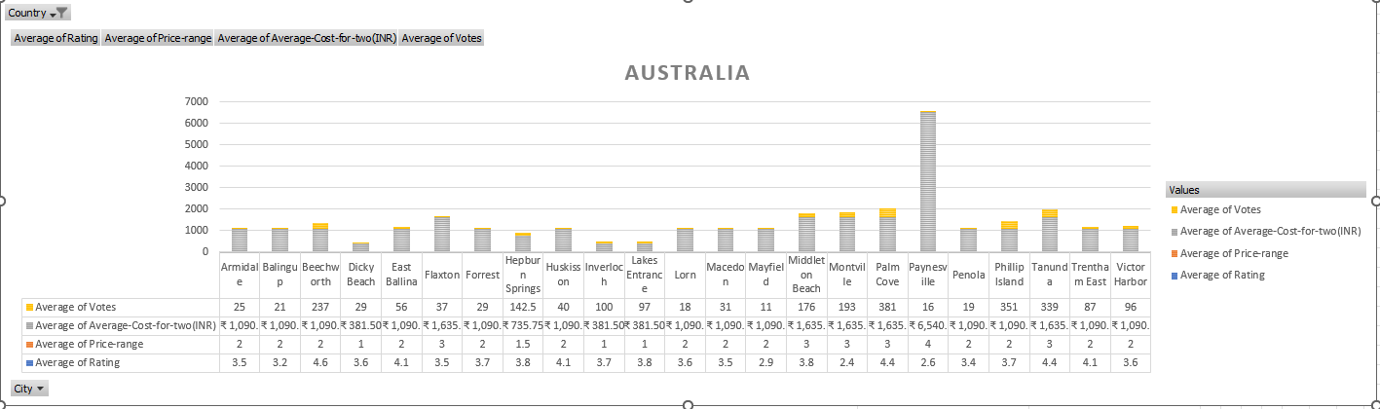
Insights
- Brazil:
  - São Paulo and Rio de Janeiro lead in both cost and rating. Most restaurants in these cities maintain ratings between 4.0–5.0 with average costs-for-two ranging from ₹ 1,900 to ₹ 4,800, reaching as high as ₹ 6,400 in premium establishments.
  - Brasília exhibits strong high-cost dining segments (₹ 3,000 – ₹ 5,000) combined with stable ratings (3–4), showing room for luxury yet approachable restaurant formats.
  - The data suggests that Jardim Paulista, Ipanema, and Leblon are top-performing sub-localities for upscale restaurant investment.
- Canada:
  - Vineland Station (₹ 4,326) shows consistently high ratings (4.0) and limited local competition.
  - Chatham-Kent reflects similar strength with balanced costs (~₹ 1,545) and ratings of 4.0.
  - These smaller but affluent communities demonstrate capacity for high-value restaurants with little saturation.
- Australia:
  - Cities such as Paynesville, Phillip Island, and Tanunda show above-average price ranges (₹ 1,600 – ₹ 6,500) with strong ratings between 3.8–4.2.
  - Paynesville particularly stands out with a high cost-for-two of ₹ 6,540, reflecting a strong tourist economy and high purchasing power for destination dining.
  - Flaxton and Montville similarly serve higher-end clientele, ideal for premium or boutique restaurant positioning.
- Singapore:
  - The city operates at a distinctly premium cost level, with most localities averaging between ₹ 4,000 and ₹ 30,000 per meal for two.
  - Marina Centre, Downtown Core, and Bukit Timah show the highest spending and consistently high ratings (~4.0).
  - This indicates Singapore as a mature but rewarding premium market where high-end or experiential dining has sustained demand.
Recommendations / Suggestions
- Brazil
Focus initial expansion in São Paulo (Jardim Paulista, Vila Mariana) to leverage established urban spending and tourism.
Consider Brasília as a second-phase development for mid-range or casual-dining chains.
Maintain menu diversity — Brazilian fusion, Italian, and Grill formats perform strongly.
- Canada
Begin pilot restaurants in Vineland Station and Consort.
These regions show strong ratings but limited restaurant variety; adding full-service dining and modern delivery integration could quickly build brand visibility.
Emphasize community-oriented service and local ingredient sourcing to align with small-town expectations.
- Australia
Open flagship locations in Phillip Island and Paynesville to capture both local and tourist audiences.
Introduce all-day menus emphasizing Australian and Mediterranean cuisine at moderate pricing.
Long-term expansion can target Montville and Beechworth once brand recognition stabilizes.
- Singapore
Expand selectively in Downtown Core and Marina Centre,City Hall as they all are close to each other, positioning the brand as a high-end dining destination focused on exclusivity, experience, and service excellence.
Prioritize experiential service quality and signature offerings to justify higher local price expectations.

Q3) According to the countries you suggested, what is the current quality regarding ratings for restaurants that are open there?

Ans:
Approach
- The dataset was filtered for Brazil, Canada, Australia, and Singapore, the shortlisted countries identified in earlier analysis.
A Pivot Table was used to calculate the Average Rating for each country and its respective cities.
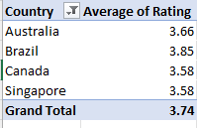

Insights
- Brazil:
The country displays strong overall performance, with most cities maintaining ratings between 4.0 and 5.0. Areas like São Paulo, Rio de Janeiro, and Brasília host consistently high-rated restaurants, especially in sub-localities such as Ipanema, Leblon.These figures reflect both high service standards and mature consumer expectations in the urban market.
- Canada:
Vineland Station and Consort maintain ratings around 4.0, suggesting excellent customer satisfaction levels despite low restaurant density. The limited number of establishments likely drives focused quality delivery, giving new entrants an opportunity to maintain high standards from beginning.
- Australia:
Regional cities such as Phillip Island, Tanunda, and Paynesville have strong ratings between 3.8 and 4.2. These smaller markets benefit from customer loyalty and personalized experiences, though occasional variability suggests opportunities to standardize operations and service quality.
- Singapore:
Ratings remain stable at approximately 3.8–4.0 across major districts like Downtown Core, Outram, and Marina Centre. Despite being a high-cost market, the quality levels are consistent rather than exceptional, indicating a competitive yet balanced dining environment.

Recommendations / Suggestions
- Brazil: Maintain focus on São Paulo and Rio de Janeiro, where ratings are already strong. Introduce experiential fine dining that reinforces the perception of quality and exclusivity.
- Canada: Preserve the high satisfaction levels in Vineland Station and Consort by implementing continuous feedback systems .
- Australia: Standardize training and service delivery in Phillip Island, Tanunda, and Paynesville to sustain the high rating benchmark as new outlets open.
- Singapore: Enhance differentiation in Downtown Core and Marina Centre through innovation in dining ambience, digital engagement, and curated culinary experiences to exceed current rating expectations.

Q4) Also, what is the current expenditure on food in the suggested countries, so we can keep our financial expenditure in control?

Approach
  - The dataset was filtered to include the shortlisted countries — Brazil, Canada, Australia, and Singapore.
A Pivot Table was created to calculate the Average Cost-for-two (INR) for each country, converting all local currency values into INR for better comparability.
A currency conversion scale was applied (using approximate standard exchange rates at the time of analysis) to ensure accurate normalization of costs across currencies such as Dollar ($), Brazilian Real (R$), and Singapore Dollar (S$).
This method enabled direct financial comparison of consumer spending levels and helped assess market affordability and profitability potential for restaurant expansion.
Formula used:
=XLOOKUP([@CountryCode],'country description'!$A$2:$A$16,'country description'!$C$2:$C$16,,0)*[@[Average-Cost-for-two]]
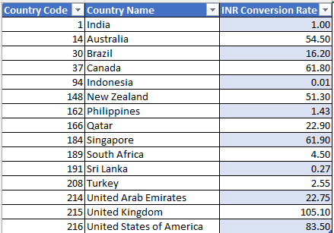

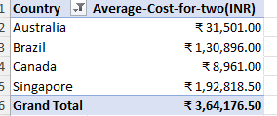

Insights

- Singapore shows the highest average expenditure, approximately ₹1,92,819.50 for two, reflecting an extremely premium and high-cost dining environment. This indicates a mature, luxury-oriented restaurant ecosystem with strong purchasing power.
- Brazil follows with an average cost-for-two of ₹1,30,896.00, showing a robust spending pattern across major cities like São Paulo and Rio de Janeiro, where fine dining and experiential restaurants dominate.
- Australia records an average cost of ₹31,501.00, representing mid- to upper-tier affordability, suitable for both luxury and casual fine-dining establishments targeting mixed audiences.
- Canada reflects the lowest average cost-for-two (₹8,961.00), suggesting that while customer satisfaction is high, the market remains price-sensitive with limited high-value restaurant penetration.

Recommendations / Suggestions
- Singapore: Focus on premium and experiential dining concepts that align with the market’s high-spend profile.
- Brazil: Develop mid-luxury to high-end offerings that balance experience with value. Introduce themed dining or chef-led menus to match the affluent urban audience in São Paulo and Rio de Janeiro.
- Australia: Maintain a flexible pricing strategy. Combine fine-dining offerings in tourist hubs with affordable premium-casual outlets.
- Canada: Implement a tiered pricing structure — offer affordable yet premium-quality menus to capture the growing middle-income segment while testing upscale variants in select cities like Vineland Station.

Q5) Come up with the names of restaurants from the recommended states that are our biggest competitors and also those that are rated in the lower brackets, i.e. 1-2 or 2-3.
Approach
The dataset was filtered for the four recommended countries — Brazil, Canada, Australia, and Singapore — and further grouped by City and Restaurant Name.
A Pivot Table was created with Votes as the primary value field to identify the top competitors (restaurants with the highest customer engagement).
For identifying low performers, ratings were filtered between 1–3 to assess potential service or quality gaps.
This two-layer analysis provided both the competitive intensity in each region and the weak-performing spaces where new restaurants can differentiate.

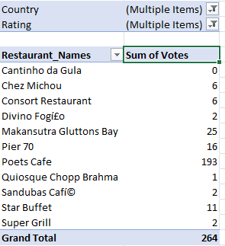

Top Competitors for Canada are -
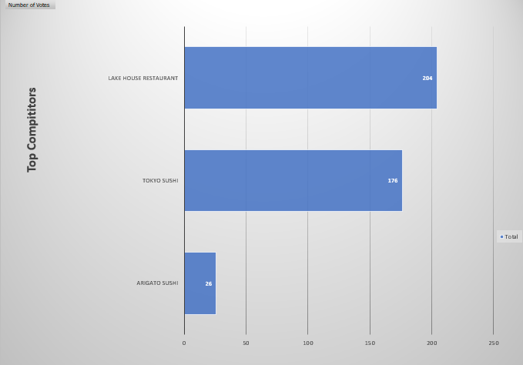

Top Competitors for Singapore are –
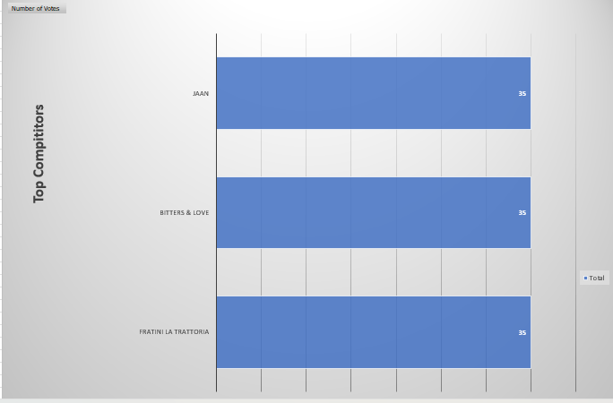

Top Competitors for Australia are –
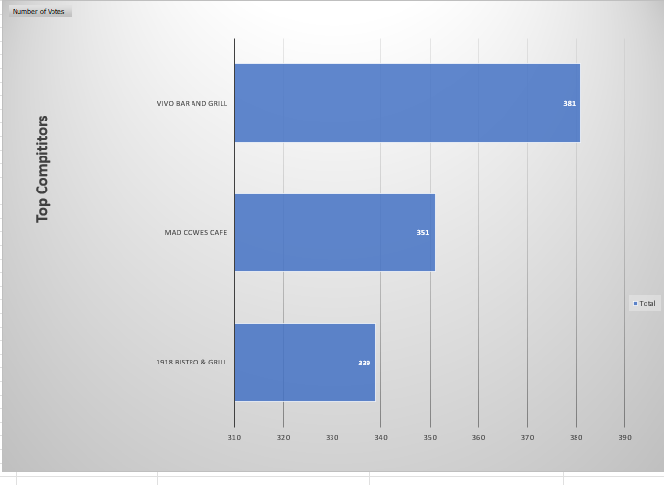
Top Competitors for Brazil are –
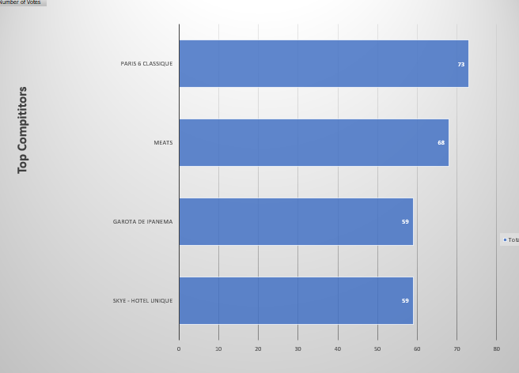

Insights
- Australia:
Vivo Bar and Grill, Mad Cowes Cafe, and 1918 Bistro & Grill are the top competitors with votes of 381, 351, and 339 respectively. These restaurants hold high engagement levels and positive ratings (4.0+), indicating a strong reputation in regions like Palm Cove, Phillip Island, and Tanunda.
- Brazil:
Major competitors include Paris 6 Classique (73 votes), Meats (68 votes), Garota de Ipanema (59 votes), and Skye – Hotel Unique (59 votes). These establishments are concentrated in São Paulo and Rio de Janeiro, with high customer interaction and ratings between 4.0–5.0. However, smaller local venues in Brasília and suburban São Paulo areas show lower ratings (below 3.0), exposing untapped potential for mid-luxury entrants.
- Canada:
The primary competitors are Lake House Restaurant (204 votes), Tokyo Sushi (176 votes), and Arigato Sushi (26 votes). The first two dominate in regions like Vineland Station and Chatham-Kent, representing established mid- to high-end dining options.
- Singapore:
Competitors such as Jaan, Bitters & Love, and Fratini La Trattoria have 35 votes each and maintain consistent ratings around 4.0. They represent high-end restaurants catering to a premium audience in Downtown Core and Bukit Timah. Lower-rated venues (3.0 or below) in nearby areas like Rochor or Kallang indicate possible market gaps for innovative mid-tier or modern fusion offerings.
Recommendations / Suggestions
- Australia: Strengthen differentiation by targeting secondary towns near Phillip Island and Tanunda where competition is weaker. Position new outlets as upscale-casual restaurants focusing on ambience and authentic Australian cuisine.
- Brazil: Avoid direct confrontation with legacy brands in central São Paulo. Instead, focus on emerging urban pockets .
- Canada: Build modern Asian or fusion restaurants in Consort and Vineland Station, introducing broader menu diversity and technology-enabled service to outperform existing competitors.
- Singapore: Establish presence near Outram and Rochor with innovative global-fusion or boutique café concepts, maintaining high-quality service .

Q6) Which cuisines should we focus on in the newer restaurants to get better feedback? Does the choice of cuisines affect the restaurant ratings?

Approach
The dataset was analyzed by Cuisine type and Country, using a Pivot Table that summarized the Sum of Votes per cuisine to identify customer popularity.
Additional analysis was conducted on Average Ratings for each cuisine to evaluate how feedback trends correlate with popularity

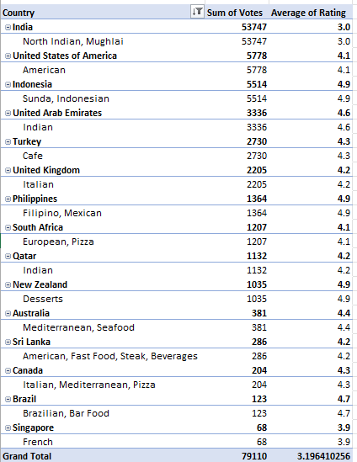

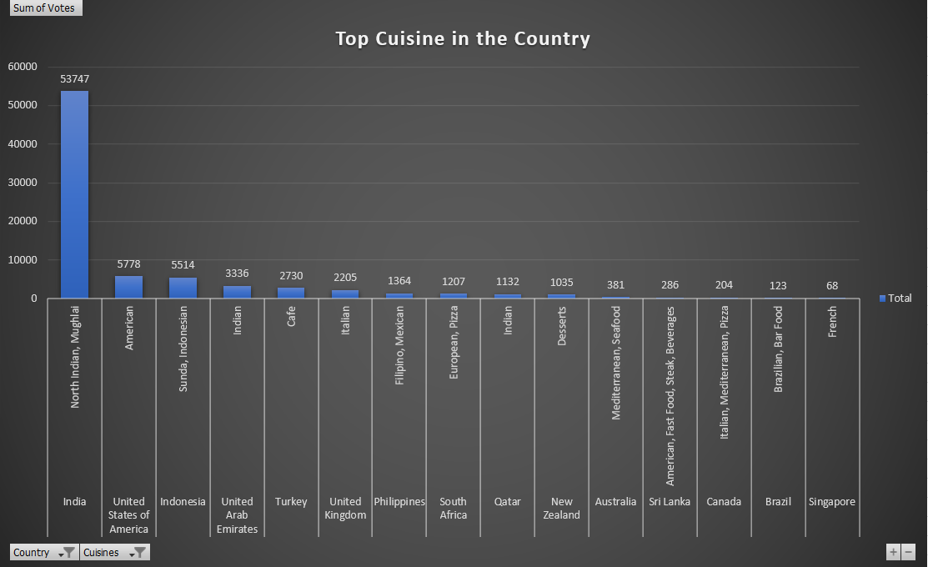

Insights

- Overall Trend:
The most popular cuisines globally are North Indian & Mughlai (53,747 votes), American (5,778 votes), and Sunda–Indonesian (5,514 votes). These cuisines attract the largest customer engagement, indicating broad appeal and familiarity among diverse audiences.
- Country-specific Observations:
  - India: North Indian and Mughlai cuisines dominate due to strong cultural resonance and established popularity.
  - United States of America & United Kingdom: American cuisine and Café-style menus gain high votes, showing preference for casual dining and comfort food experiences.
  - Indonesia and UAE: Regional and fusion cuisines such as Sunda–Indonesian and Indian remain widely favored, demonstrating the success of local–ethnic blends.
  - Australia and Canada: Mediterranean and Italian cuisines show consistent engagement, indicating acceptance of light, diverse flavors suited to high-income consumers.
  - Brazil and Singapore: Brazilian Bar Food and French cuisines appear less frequent but maintain niche appeal in premium fine-dining contexts.
- Correlation with Ratings:
Cuisines with high engagement (Indian, American, Mediterranean, Italian) tend to maintain average-to-high ratings (3.5–4.2).
Less popular cuisines, while niche, often show higher per-restaurant ratings due to exclusivity and differentiated dining experiences — particularly in fine-dining markets like Singapore.

Recommendations / Suggestions
- Primary Focus:
Prioritize Mediterranean, Italian, and Modern Australian cuisines in global markets like Australia, Brazil, and Canada, where international flavors and high-cost dining preferences align well with consumer expectations.
- Secondary Focus:
Introduce Fusion and Continental menus in developing premium regions such as Brazil and Singapore, targeting adventurous, affluent diners open to new flavors.
- Market Strategy:
  - Maintain a localized twist on high-performing cuisines — for instance, Mediterranean-Asian fusion in Singapore or Italian-Brazilian in São Paulo.
  - Emphasize menu consistency, presentation quality, and freshness to sustain high ratings.
  - Avoid over-diversification; instead, focus on 2–3 cuisine types.

Q7) According to our current data, should we go for online delivery and table booking? Does that affect the customer’s ratings?

Approach

The dataset was analyzed using a two-variable pivot comparison between the features Has-Table-booking and Has-Online-delivery against two key performance indicators — Average Rating and Average Cost-for-two (INR).
Separate pivot summaries were prepared: one to measure how these facilities influence customer satisfaction (rating), and another to evaluate their impact on spending behavior (cost).
The purpose was to determine whether offering both options leads to higher customer perception and profitability, thereby guiding service inclusion decisions for new restaurants.

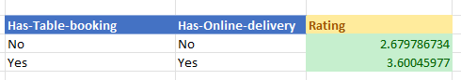

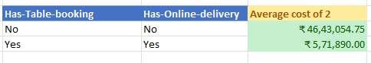

Insights
- Customer Rating Impact:
Restaurants with both online delivery and table booking show a notably higher average rating of 3.60, compared to 2.68 for those without either feature.
This 0.92-point increase indicates that accessibility and convenience directly enhance customer satisfaction and brand loyalty.
Customers prefer establishments that offer flexibility
- Cost and Pricing Behavior:
Outlets providing these services also show a significantly lower average cost-for-two (₹5,71,890) compared to ₹46,43,054 for those lacking both.
This contrast reflects an operational pattern — restaurants offering online or booking facilities are typically mid-range to premium casual, while those without such features skew toward exclusive fine-dining with higher pricing and limited accessibility.
- Overall Relationship:
The combination of higher customer ratings and lower average cost implies that introducing online delivery and table booking creates a balanced business model — maintaining strong satisfaction while controlling per-customer expenditure and improving service scalability.

Recommendations / Suggestions
- Adopt Both Services: Implement online delivery and table booking capabilities as standard offerings across all new restaurant launches. These drive higher satisfaction, visibility, and customer retention while optimizing operational reach.
- Technology Integration: Use unified platforms for booking and delivery management to streamline orders, reduce wait times, and improve service consistency.
- Customer Experience Management: Encourage post-delivery and post-dine feedback loops to continually monitor satisfaction scores and address service gaps.
- Pricing Strategy: Maintain competitive mid-premium pricing to attract both dine-in and online customers, ensuring profitability while sustaining accessibility.

Q8) Should the team keep the rate of cuisines higher? Will that affect the feedback? According to our data are the rates of cuisines and ratings, correlated?

Approach
A Correlation Analysis was performed between Rating and Average-Cost-for-two (INR) to determine whether restaurant pricing has any measurable relationship with customer satisfaction.
The analysis used Pearson’s Correlation Coefficient (r), which quantifies the direction and strength of a linear relationship between the two variables.
In this test:
- Rating was the dependent variable (indicator of customer satisfaction).
- Average-Cost-for-two represented the independent variable (pricing level).
A correlation coefficient value between -1 and +1 was interpreted to understand whether higher costs are associated with better or worse ratings.
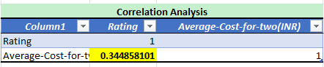
Insights
- The calculated correlation coefficient (r) = 0.3449, indicating a moderate positive relationship between price and rating.
- This means that as restaurant prices increase, ratings also tend to rise slightly — suggesting customers often associate higher pricing with better quality or premium experiences.
- However, since the correlation is not strong (r < 0.5), the relationship is not absolute.
Many mid-range restaurants with reasonable prices still maintain high ratings due to good service, convenience, and food quality.
- The analysis therefore implies that pricing influences perception to some extent but does not guarantee higher customer satisfaction.
Recommendations / Suggestions

- Pricing Strategy: Maintain a balanced premium pricing model — keep prices slightly above the market average to reflect quality but not so high as to deter mid-income customers.
- Value Communication: Focus on value-for-money positioning through quality ingredients, service consistency, and ambience, ensuring customers perceive worth at any price point.

Q9) What is the distribution of the number of restaurants of different price ranges in all the countries?

Approach

A Pivot Table was created using Country as rows and Price Range (1–4) as columns, with Number of Restaurants as values.
This structure allowed clear comparison of how restaurants are distributed across pricing tiers (1 = low-cost to 4 = high-cost).
To visualize market dominance, a Pie Chart was prepared comparing countries with the largest restaurant counts, highlighting proportional representation.
The analysis focuses on identifying countries with high restaurant density and understanding which pricing categories dominate in each market.
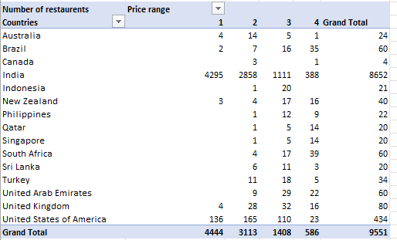
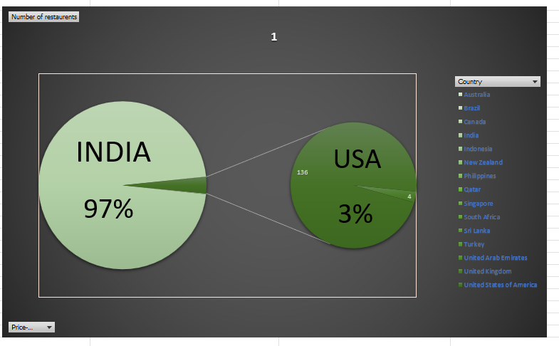

Insights
- India accounts for the overwhelming majority of restaurants, comprising nearly 97% of the total dataset (8,652 of 9,551 restaurants). The distribution within India is skewed toward lower price ranges —
  - Price Range 1: 4,295 restaurants
  - Price Range 2: 2,858
  - Price Range 3: 1,111
  - Price Range 4: 388
This pattern shows India’s market as predominantly affordable, catering to mass consumers with limited premium presence.
- United States of America ranks a distant second with 434 restaurants (≈3% of total), showing a more balanced spread across price ranges, particularly 2 and 3.
- Other countries such as Brazil (60) and South Africa (60) demonstrate smaller but more balanced high-end presence, while nations like United Kingdom, UAE, and Singapore show moderate representation, suggesting mature but niche markets.
- The dataset reveals that most global markets exhibit smaller sample sizes, with India’s low-to-mid-priced restaurants dominating the overall distribution curve.
Recommendations / Suggestions
- Market Focus:
High restaurant density in India indicates market maturity and competition saturation. New entrants should adopt differentiated strategies — such as theme-based restaurants, niche cuisines, or premium experiences — rather than mass-market approaches.
- Premium Segment Expansion:
Countries like Brazil, South Africa, and UAE show promise for growth in price ranges 3 and 4, where demand for upscale dining is increasing but supply remains relatively low.

Q10) Explain your approach in brief for suggesting countries/cities in order to open new restaurants, if the objective and subjective questions would have not been given to assist you. [you have to give bullet pointers in order to answer this question]
  - I would have looked at how many categories I have in the raw data sheet
  - I would have done some data cleaning if any and made new coulumns as per my convenience
  - Remove duplicates, handle missing or inconsistent values, and ensure correct data types (numeric for cost, text for categorical fields).
  - Use Pivot Tables to find average ratings and cost levels per country and city.
  - Apply COUNTIFS / AVERAGEIFS formulas to detect high-rating, high-cost areas with fewer restaurants (indicating low competition)
  - I would also split the cuisines into individual ones and find out the single most popular dish in each country and city
  - I would add city slicers in addition to year and country slicers
  - I would find high priced , medium prised and low prised restaurants and compared them to given ratings and see their correlation
  - I would find geographically least competitive areas and still moderately priced to recommend new places .

